Type | Flow Rate [GPM] | Total Head [ft] | Motor Power [HP] | Pump Speed [RPM] | Aprox FLA (460V) | Frame Size | Impeller parementer [inch] | Manufacture | Model
Duty Pump | 85 | 50 | 2 | 1750 | 4 | 182T | 7 | Bell & Gossett | Series 1510
Standby Pump | 85 | 50 | 2 | 1750 | 4 | 182T | 7 | Bell & Gossett | Series 1510

Geothermal water pumps & heat pumps Operation Control
On | economizer and desiccant wheel cannot maintain comfort conditions due to extremes in outside weather conditions
Off | economizer and desiccant wheel can maintain comfort conditions due to extremes in outside weather conditions

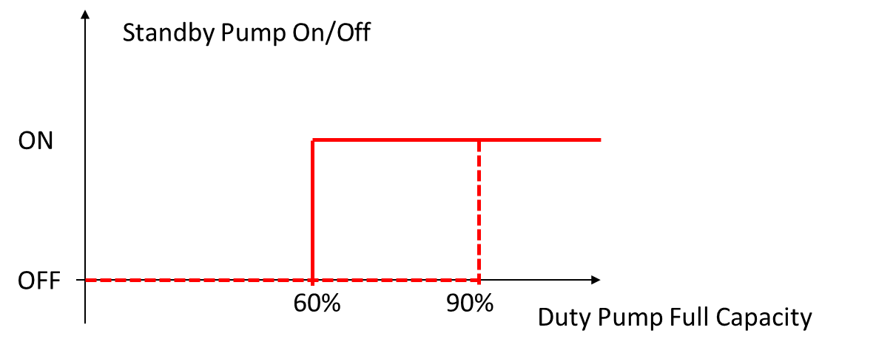
Control of the Water Pump
Duty Pump | Standby Pump | Condition
√ |  | As the Geothermal system on
√ | √ | Setpoint control
 | √ | Duty pump failure

